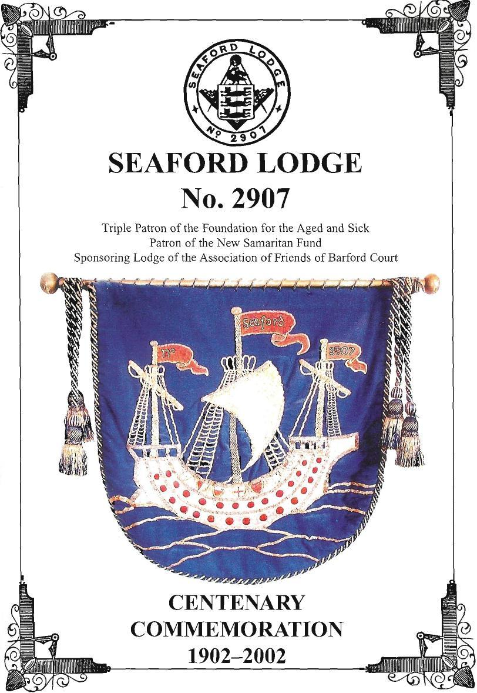

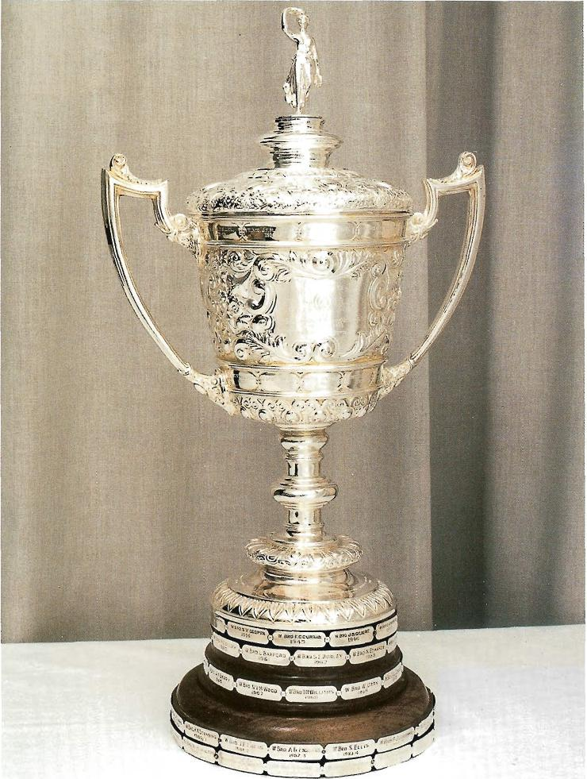

The Seaford Lodge Loving Cup
The solid silver loving cup was presented by W Bro. James S. Burroughs in 1906. Around the base is inscribed the name of every Worshipful Master and his ear in Office.
The loving cup is regularly displayed at our festive boards and used at least once a year.
CENTENARY COMMEMORATION
SEAFORD LODGE No. 2907
Introduction
The celebration of the centenary of Seaford Lodge is an appropriate occasion to produce this history of the Lodge from its beginning to the present day.
The aim of this history is not only to give some details of what has happened in the Lodge but also to try to convey something of how times have changed during this period, the personalities of its members and how the Lodge has been influenced by the vast majority of its members either living or working in Seaford.
A good example of the change in society is that the occupation of two of its founder members was given as a "Gentleman", something quite unheard of in today's fast moving society.
Three distinguished members worth a special mention here are: Viscount Selby, Speaker of the House of Commons from 1895 to 1905; Joe Deegan who, in Kenya in 1952, informed Princess Elizabeth of the death of her father, King George VI, and proclaimed her as Queen and Sir Leonard Barford, who was H.M. Chief Inspector of Taxes in the 1970s and went on to become Provincial Grand Master of Sussex from 1979 to 1990.
Our thanks must go to Worshipful Brothers Ted Shepherd, John Heritage and Fred Howe for the time they have spent researching this history, with many "nostalgic" hours being spent in the County Archives in Lewes where a considerable amount of the Lodge's past records are now stored. Also to Worshipful Brother Robert Martin for editing and providing additional material and Worshipful Brother John Fuller who was responsible for further editing and producing the final document. A real team effort overall.
We hope you enjoy reading it.
1

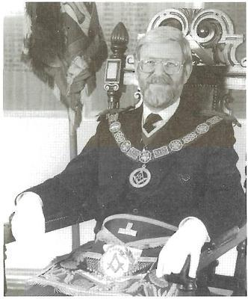

Foreword by
R.W. PROVINCIAL GRAND MASTER
IAN H. LAY
It is a wonderful milestone to attain a century. I offer my congratulations to you all.
I offer my congratulations and thanks to all those responsible for compiling and writing this short History.
Some people think that a Lodge is a building but it is not. It is the sum total of its members. We must remember that a Lodge is a living thing like a tree. You plant it with high hopes and it is tendered gently in its formative years. Sometimes it is mistreated and instead of putting on girth, shrinks. We must always remember that anything that is living needs regular feeding and care. Seaford Lodge has been well tendered over the years. It has been able to boast of well-known public servants but the majority of its members have been ordinary members of society. Through their membership of Seaford Lodge they will have become better citizens and able to make a positive contribution to their community.
Please continue to tend your Lodge so that during the next hundred years it will continue as a strong, vibrant living body of just, upright and fit men of sound judgment and strict morals.
Ian H. Lay
Provincial Grand Master
March 2002

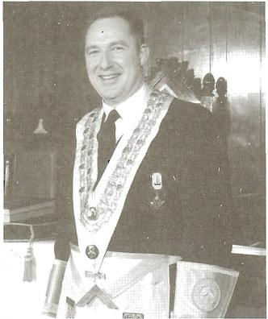

100th WORSHIPFUL MASTER OF SEAFORD LODGE
PAUL K. ROGERS
Although I have been associated with Seaford Lodge for only a short period, I feel honoured to be its 100th Master and privileged to join the long line of eminent men who have ruled and governed the Lodge.
More senior Brethren may well recall some of the important and significant events recorded by those who have compiled this history.
It is a story of dedication, hard work and charitable effort that spans the first hundred years and which makes up the life of this distinguished Lodge.
We will never know the characters, the thoughts, hopes, aspirations and disappointments of those devoted Brethren who served the Lodge in its earlier years. Our brief and incomplete records do not reveal this. We do however, enjoy the heritage they built for us, as they gave part of themselves to establish the foundations and traditions of Seaford Lodge. Their legacy inspires us to work for Freemasonry in the best way we can and this history is dedicated to them.
Paul K. Rogers
Worshipful Master; Seaford Lodge
March 2002

PETITION FOR A NEW LODGE
(See Book of Constitution, Rule 116, Edition 1896)
TO THE MOST WORSHIPFUL GRAND MASTER OF THE UNITED FRATERNITY OF ANCIENT FREE AND ACCEPTED MASONS OF ENGLAND.
We the Undersigned being regularly Master Masons of the Lodges mentioned against our respective names, having the prosperity of the Craft at heart, are anxious to exert our best endeavours to promote and diffuse the genuine principles of the Art, and, for the conveniency of our respective dwellings and other good reasons, we are desirous of forming a new Lodge to be names.
SEAFORD LODGE
In consequence of this desire we pray for a Warrant of Constitution empowering us to meet as a regular Lodge at THE BAY HOTEL, SEAFORD on the third Friday of every month, and there to discharge the duties of Masonry, in a constitutional manner, according to the forms of the Order and the laws of the Grand Lodge; and we have nominated and do recommend BRO. PHILIP S. LEE to be the first MASTER. BRO. F.C. HERBERT to be the SENIOR WARDEN and BRO. F.M. HART1N to be the first JUNIOR WARDEN of the said Lodge.
`THE PRAYER OF THIS PETITION BEING GRANTED WE PROMISE STRICT OBEDIENCE TO THE COMMANDS OF THE GRAND MASTER AND THE LAWS AND REGULATIONS OF THE GRAND LODGE.'
(Signed by the Petitioners)
This Petition is recommended for the favourable consideration of the Most Worshipful Grand Master by the Officers of the South Saxon Lodge No. 311 Meeting at Freemasons Hall Lewes.
Signed, Harold Granger W.M.
G.F.W. Husse S.W.
20 February 1902

Founder Members of
Seaford Lodge No. 2907
William Cout Guilly | Speaker, House of Commons (Northern Bar Lodge No. 1610)
F.M. Hartung | Insurance Broker (Royal Somerset Lodge No. 4)
Thomas Wakley Jnr | Medical Doctor (Cheselden Lodge No. 2870)
F.C. Herbert | Gentleman (Strong Man Lodge No. 45)
Walter Gates | Major, lst Sussex R.E. (Vols) (Pelham Lodge No. 1303)
Philip S. Lee | Surveyor (Pelham Lodge No. 1303)
J. Ernest Lane | Surgeon (Royal Hampton Court Lodge No. 2183)
Frederick H. Gervis | Surgeon (Hampstead Lodge No. 2408)
William Pringle Mogan | Surgeon (South Saxon Lodge No. 311)
Albert Pierce Hadlow | Proprietor, Wellington Hotel (South Saxon Lodge No. 311)
Lauchlan Cameron | Pharmaceutical Chemist (South Saxon Lodge No. 311)
Charles Berkeley Gervis | Surgeon (Hampstead Lodge No. 2408)
G. Kinsy Meares | C.E. (Lion Lodge No. 312)
J. F. Plaister | Gentleman (South Saxon Lodge No. 311)
C.S. Murray | Surgeon (Sancta Maria Lodge No. 2682)
William Cooper | Architect & Surveyor (Derwent Lodge No. 40)
William Henry Horsley | Barrister (Chancery Bar Lodge No. 2456)
T. Stirling Jnr | Merchant (Guildhall School of Music Lodge No. 2454)
Lewis Thomas Crook | Major, Honourable Artillery Company (Fitzroy Lodge No. 569)
J. W Stedman | Proprietor, Star Hotel, Alfriston (South Saxon Lodge No. 311)
Albert Stone | Brewer (South Saxon Lodge No. 311)

Seaford Lodge No. 2907
Officers 1902-1903

Worshipful Master | W | Bro. P.S. Lee
Senior Warden | W | Bro. F.C. Herbert
Junior Warden | W | Bro. F.M. Hartung
Treasurer |  | Bro. L. Cameron
Secretary |  | Bro. C.B. Gervis
Senior Deacon |  | Bro. J. F. Plaister
Junior Deacon |  | Bro. W.P. Morgan
Director of Ceremonies |  | Bro. C.S. Murray
Inner Guard |  | Bro. P. Stirling Jnr.
Senior Steward |  | Bro. S. Stone
Junior Steward |  | Bro. G.K. Meares
Tyler |  | Bro. E. E. Foster

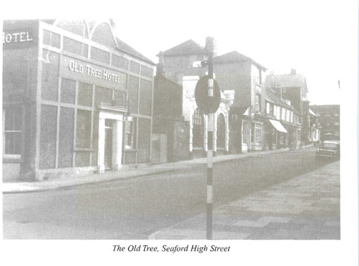

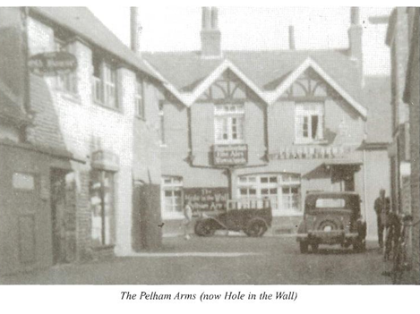

Freemasonry in Seaford
The Royal Cinque Port Lodge No. 566
Seaford Lodge No. 2907 is not the first Lodge to have been formed in Seaford. Grand Lodge records indicate that on 28th September 1797, The Royal Cinque Port Lodge was warranted as Lodge No. 566, to meet at the Old Tree Inn, Seaford, which stood at the junction of Broad Street and High Street on the site now occupied by "Friday-Ad".
The consecration of the Royal Cinque Port Lodge took place on 7th November 1797 and the founders were James Cook, Junior. William Hamilton, Nathaniel Beard, John Kinningburgh, Morgan Davies, John McDoll, Henry Reed, William Wood, Ephraim Inksett and John Perry. The First Master was Bro. James Cook, Junior, and the Senior and Junior Wardens were Bro. William Hamilton and Bro. Nathaniel Beard.
In 1801 the Lodge transferred to the Pelham Arms Inn, just off High Street (now The Hole in the Wall) and in 1803 the Lodge was meeting at a private room in Seaford. In 1822 the Lodge returned to the Old Tree Inn, having been re-numbered 587 after the Union of the Grand Lodges in 1814.
Attendances, however, were dwindling, with the consequence that after its meeting in Seaford on 31st December 1822, and a successful petition, the Lodge became the Royal York Lodge No. 587, and transferred to the Royal York Hotel, Brighton.
The volume of the Sacred Law, a Breeches Bible published in 1589, and the Book of Constitutions published in 1774 both of which were used at the Consecration on 7th November 1797, are still in the possession of the Royal York Lodge. Seaford remained without a Lodge until 1901 when 21 Masons with the blessing of South Saxon Lodge No. 311, petitioned for the formation of a new Lodge and it is this new Lodge No. 2907 whose one hundredth anniversary we are now celebrating.

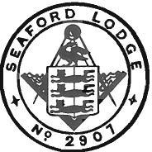

SEAFORD LODGE No. 2907

Date of Warrant — 4th March 1902

Consecrated

on the 11th April 1902

at the

Queen's Hall, Seaford

By

V.W. Bro. The V Rev. E.R. Currie, D.D., P.G. Chaplain

assisted by

W. Bro. O.N. WYATT Prov. S.G. Warden
W. Bro. F. CARR Prov. J.G. Warden
W. Bro. H.G. JAMESON Prov. G. Chaplain
W. Bro. GEO. SMITH Prov. G.D. of C.
W Bro. T. HAMLIN Prov. G.I.G

Installing Master W. Bro. W. DAWES, P.G. Deacon

First Master W. Bro. P. S. LEE (P.M. 1303)
I.P.M. W. Bro. F.H. GERVIS (P.M. 2408)
S.W W. Bro. F.C. HERBERT (P.M. 45)
J.W. W Bro. F.M. HARTUNG (P.M.4)

Freemasonry in Seaford

The Royal Cinque Port Lodge No.566

Seaford Lodge No.2907 is not the first Lodge to have been formed in Seaford. Grand Lodge records indicate that on 28th September 1797, The Royal Cinque Port Lodge was warranted as Lodge No.566, to meet at the Old Tree Inn, Seaford, which stood at the junction of Broad Street and High Street on the site now occupied by "Friday-Ad".
The consecration of The Royal Cinque Port Lodge took place on 7th November 1797 and the founders were James Cook, Junior, William Hamilton, Nathaniel Beard, John Kinningburgh, Morgan Davies, John McDoll, Henry Reed, William Wood, Ephriam Inksett and John Perry. The First Master was Bro. James Cook, Junior, and the Senior and Junior Wardens were Bro. William Hamilton and Bro. Nathaniel Beard.
In 1801 the Lodge transferred to the Pelham Arms Inn, just off High Street (now The Hole in the Wall) and in 1803 the Lodge was meeting at a private room in Seaford. In 1822 the Lodge returned to the Old Tree Inn, having been re-numbered 587 after the Union of the Grand Lodges in 1814.
Attendances, however, were dwindling, with the consequence that after its meeting in Seaford on 31st December 1822, and a successful petition, the Lodge became the Royal York Lodge No.587, and transferred to the Royal York Hotel, Brighton.
The volume of the Sacred Law, a Breeches Bible published in 1589, and the Book of Constitutions published in 1774 both of which were used at the Consecration on 7th November 1797, are still in the possession of the Royal York Lodge. Seaford remained without a Lodge until 1901 when 21 Masons, with the blessing of South Saxon Lodge No.311, petitioned for the formation of a new Lodge and it is this new Lodge No 2907 whose one hundredth anniversary we are now celebrating.

Seaford Lodge No 2907
The First Hundred Years

1902
Seaford Lodge was consecrated on 11 April at the Queen’s Hall, Seaford by V W Bro The Rev E R Currie DD, Past Grand Chaplain, the Dean of Battle assisted by five Provincial Grand Officers. W Bro W Davies Past Grand Deacon installed W Bro Phillip S Lee as the first Master of the Lodge. Four candidates for initiation were also proposed before the meeting was closed. A banquet was held at the Bay Hotel, Seaford, which was the meeting place for the Lodge for the next two years.
At the first Lodge meeting, which was held only one week later, the four candidates proposed at the consecration meeting were initiated.
A further meeting followed on 16 May. Opening at 5:45pm it started with three of the Entered Apprentices initiated at the previous meeting answering the questions leading to the Second Degree. One visitor then answered the questions leading to the Third Degree and was raised to the rank of Master Mason. He was then proposed as a joining member. By then the fourth Entered Apprentice initiated at the previous meeting had arrived to answer the questions leading to the Second Degree. The Lodge then approved its by-laws and thanked Bro Plaister for donating his harmonium to the Lodge. The four Entered Apprentices were then passed to the Second Degree and after the explanation of the Second Tracing Board the meeting was closed at 8:30pm. This was some agenda and some achievement for 2¾ hours.

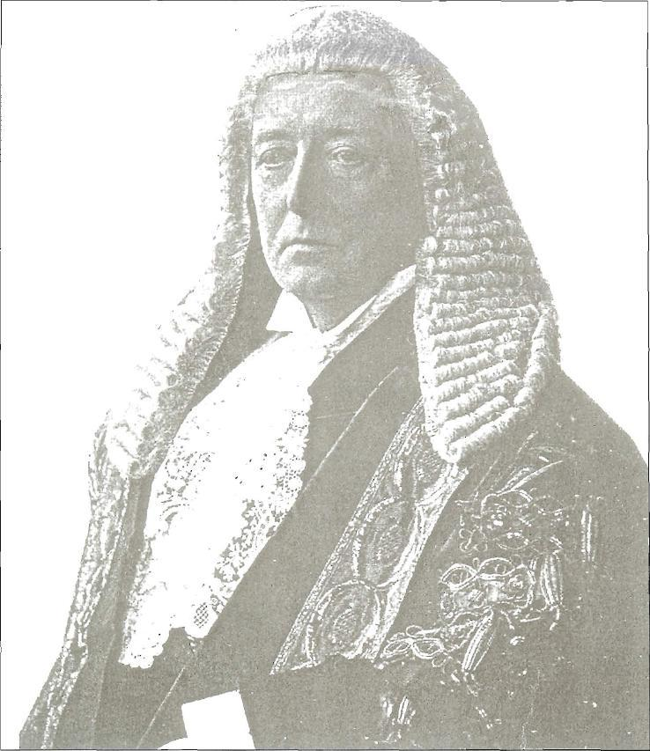

William Court Gully
Born 1835, Died in 1909

A Founder Member of the Lodge, he was called to the bar in 1860 and became a QC in 1877. He was a keen Liberal and became an MP for Carlisle in 1886. He was elected Speaker of the House of Commons in 1895 and resigned in 1905 when he was created Viscount Selby.

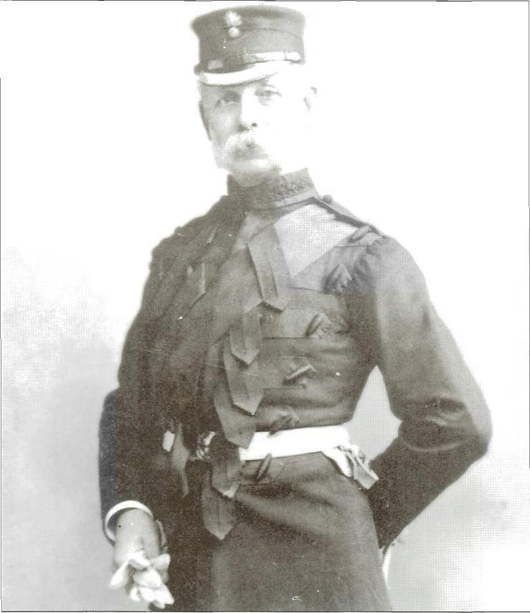

Major Lewis T Crook
A founder member of Seaford Lodge, Major L T Crook was in the Honourable Artillery Company and lived in Seaford for many years. He was the penultimate bailiff of Seaford in 1884 and a great supporter of local associations becoming at one time the Superintendent of the Congregational Sunday School and President of the Football and Cricket Clubs.

The Lodge by-laws approved at the May meeting, provided for seven meetings a year to be held on the third Fridays of January through May, September and October with the Installation meeting in April.
An emergency meeting on 20 June “to ease the labours of the September meeting” followed the marathon meeting on 16 May. This meeting opened at 6 pm and after two Fellow-crafts were separately raised two candidates were initiated: the meeting closed at 8:45pm.
At the next meeting in September, two Fellow-crafts were separately raised and two Entered Apprentices were passed. In addition, Bro Dawes presented an ivory gavel to the Lodge, which is still used by the Lodge today.
By the next meeting in October, things had started to settle to a more normal level. Indeed, the Lodge did not open until 7pm when two Fellow-crafts were separately raised to the rank of Master Mason.

1903
The first Installation meeting was held in April at the Albert Hall, East Street, Seaford (a site now occupied by a block of flats adjacent to the telephone exchange and facing down the High Street). The meeting opened at 4pm and W Bro Phillip S Lee was re-installed as W Master for a second year. Following his re-installation, W Bro Lee presented a very handsome Banner to the Lodge “in gratitude to the Great Architect of the Universe for being able to carry out the duties of Worshipful Master for the past year”. The meeting closed at 6.15pm and was followed by a banquet at the Bay Hotel.
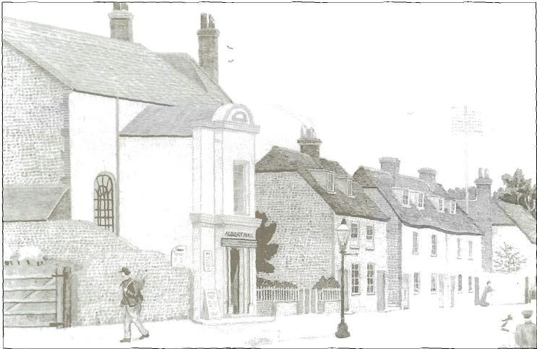

Albert Hall, East Street

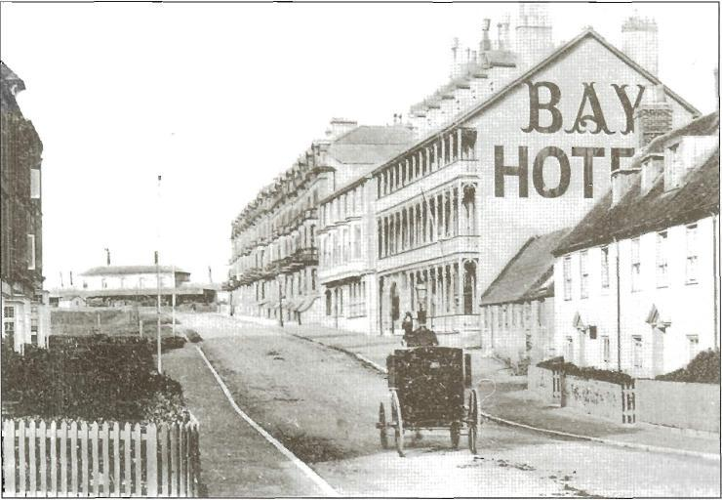

The Bay Hotel, Pelham. Road

It is interesting to note that the Lodge Banner was not dedicated then and it was not until the Lodge’s 75th anniversary that this oversight was rectified.
The Lodge voted to accept the recommendations of Grand Lodge that there should be no drinking in Lodge meetings – it had been common practice to toast the Worshipful Master during meetings, particularly during Installation meetings.
1904
The Bay Hotel, which had been regularly used for both Lodge meetings and festive boards, was by now proving too small for Lodge Meetings so the Lodge moved to the Simmons Institute in Crouch Lane, Seaford (subsequently used as a workshop by Seaford Antiques and now converted to housing units) for the meeting in January 1904. The Lodge continued to meet there until 1939 but the Festive Boards were held at the Bay Hotel until the mid 1930s.
At the February meeting, the W Bro T S Lee, the brother and a guest of the Worshipful Master (W Bro P S Lee), took the Chair as Worshipful Master. W Bro P S Lee was ill at the time and missed this meeting and the next two meetings as well.
1905
William Gully one of the founder members, residing at Sutton Place, Seaford (now part of Newlands School) was created Viscount Selby on retiring from his Office as Speaker of the House of Commons. Viscount Gully was a Barrister having been called to the bar in 1860. He became Liberal MP for Carlisle in 1886 and was elected Speaker in 1895. He was reported to have gained the respect and affection of every quarter of the House of Commons during his ten-year period of tenure and virtually outlawed the “supplementary question”. He resigned as Speaker in 1905 and died in 1909.
1906
The requirement for a local Tyler was now apparent as the Tyler at that time lived in Peacehaven. The difficulties in transport, the frequent opening of the bridge over the River Ouse in Newhaven together with the very busy level crossing made it difficult for him to attend the meetings in sufficient time to prepare the Lodge. By dispensation Mr Arthur Simons, a Fly-Driver (a “fly” is a one-horse hackney carriage) living only a stones throw from the Simons Institute, was initiated at the June meeting and in due course was followed by his son Leonard. Together they served the Lodge as Tyler for the next 59 years.
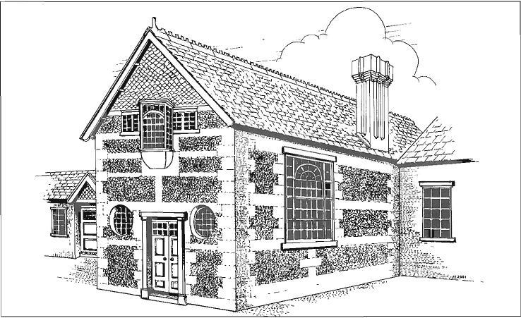

Simmonds Institute Seaford

At the same meeting, W Bro James S Burroughs presented the Lodge with a solid silver loving cup to commemorate the Worshipful Master’s year of Office and his own initiation into the Lodge. The loving cup is now regularly displayed at our festive boards and used at least once every year.
At the July meeting the Lodge was pleased to support the petition of South Saxon Lodge No 311 for the formation of Homestreu Lodge No 3277 in Newhaven: the Lodge subsequently loaned Homestreu Lodge their Tracing Boards for the Consecration Meeting.
On a less happy note, the minutes of the October meeting recorded the death of several Masons of a local Lodge, Ockenden No 1465 (who met in Balcombe), in a “motor omnibus” accident at Handcross, with a request for help to alleviate the distress of their widows.
1908
This year it was agreed to change the dates of the Lodge meetings to the second Fridays in January through May, October and November with April continuing as the Installation meeting.

At the October meeting, the current Master, W Bro Lauchlin Cameron, who was one of the founder members and owned the Pharmaceutical Chemist Shop in Broad Street, Seaford (which is still there today), donated a broken column to stand on the Secretary’s table for unsolicited donations, there being no specific collection of Alms at that time.

Concerning charity donations, the minutes of the Lodge at this time record that support for the Masonic Charity notified by the Province was organised by the Lodge, adding its own contribution to a donation from the Provincial Charity Office. The amount was then taken or sent to the Grand Lodge Festival meeting by the Lodge’s designated Charity Representative (there being no formal Office of Charity Steward at that time).

1909

In this year, the Tyler (Bro Simons) took the Lodge Banner to the Provincial Grand Lodge Meeting for the first time. A note in the minutes shows that the Lodge paid the Tyler 5 shillings a week while he was ill.

1910

At the May meeting Bro Louis Mosley was initiated: W Bro Mosley was
Master of the Lodge in 1915 and served as Secretary for some forty years holding the office between 1912 and 1913, 1916 and 1949 and finally between 1951 and 1955. He received Grand Honours by being promoted to Past Assistant Grand Director of Ceremonies in 1946.

1913

In this year a letter was received from Provincial Grand Lodge suggesting that “there were too many Masons being admitted just to swell Lodge numbers, leading to many petitions for pecuniary assistance totalling some £200,000 a year”. It recommended a minimum Initiation fee of 10 guineas and “careful consideration of an applicant’s financial status”. In response the Lodge, voted at the April meeting, to increase its Initiation fee to 7 guineas and the annual subscription fee of 2 guineas (£2.10).

1914

The Lodge of Instruction (LOI) was established together with the adoption of its By-laws and has met on a regular basis ever since. The LOI has been held in numerous places in Seaford over the years – among the premises used were: Moats (which was an upstairs room over “Grannies Café”), Grannies Café itself, which was in Clinton Place where Lampons the Estate Agents is now, a room at Seaford Head Golf Club and in the 1970s a “hut” at the District Offices (now the Down Leisure Centre). The LOI now meets at Jerrom Hall in Peacehaven.
With the commencement of World War I, meetings continued and did so for the duration of the conflict: however many of the meetings were held without ceremonies. The minutes also show that four Lodge members were on active service in France.

1915

The meeting dates of the Lodge were changed once again. Following a brief experimentation with Saturdays, the meeting dates were settled as the third Fridays in January through May, October and November with April continuing as the Installation meeting.

With the changes brought about by the War the Lodge membership stood at 24 the lowest number recorded in the Lodge’s history

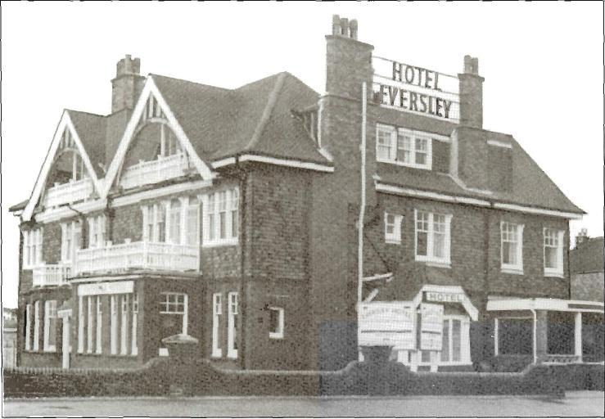

Eversley Hotel (now Beachcomber)

1917
At the meeting on 19th January, the Lodge’s long links with Canada were established when 19 Masons in the Canadian Forces were welcomed to the meeting. Subsequently a number of Canadian soldiers were initiated into the Lodge but sadly one of them, Sergeant Hunter, was killed in action on 19th April 1917. Another Canadian, RSM Reeves was initiated into the Lodge but raised by Radnor Lodge No 2587 on 18 April 1917 following his posting to the Folkestone area.

Pioneer Lodge No 420 of the Irish Constitution left its mark on the Lodge by “borrowing” our Tyler’s Collar and its Jewel for ceremonies they held on the battlefield of Flanders. True to Masonic principles, the Collar and Jewel were returned with a letter of their appreciation and thanks reading:

“This collar was restored to Seaford Lodge by Pioneers Lodge No 420 (Ulster Division). It was worn at several Communications during the Great War from 1915 –1918”

The collar can be seen in a display cabinet at the East Brighton Masonic Centre, together with a history of the Pioneer Lodge during the War period, which includes details of a number of meetings held under fire near the front line.

1918

During this year, Seaford Lodge initiated, passed and raised a number of Canadian Officers at the request of other Lodges eg three officers were, by Dispensation, raised at the October meeting at the request of Hythe Lodge No. 2546 in the Province of Hampshire and Isle of Wight.

1921

This year the Lodge fees were raised to 3 guineas (£3.15p) with an Initiation fee of 12 guineas (£12.25p). In addition a “Fee of Honour” was introduced with a fee of 3 guineas for the Worshipful Master and 1 guinea both the Senior and Junior Wardens. There is no record of any changes to these “Fees of Honour” and they were finally discontinued in 1946.

1922

In order to acquire its own premises, the Lodge established a building fund and this marked the beginning of a fifty-year search for a permanent location - see details in Meeting and Dining.

A surprising entry in the Lodge’s records for this year is a copy of the programme for the Installation Dinner of the Royal York Lodge (by then renumbered 315) on 4 April 1922. The menu starts with “Native Oysters” – a possible recognition of the Royal York Lodge’s origins in the fishing town of Seaford in 1797.

1925

W Bro W.J. Woods was installed as the twenty-fourth Master – he was the proprietor of “Woods Stores” and also owned Woods China shop and Wood’s Removals.

1926

W Bro L.P. (Percy) Leman was installed as the twenty-fifth Master: he was a Dentist with a practice in Broad Street. He was a larger than life character and was well known for lunching at Dorothy’s Café and then repairing to an upstairs room to play the piano for an hour or more before returning to his dentistry. He was appointed Provincial Grand Organist in 1934.

At the Installation Meeting this year there were 50 present and a note in the minutes reads “Freemasonry becoming more popular”.

1928

W Bro G.T. (Tom) Godfrey was installed as the twenty-seventh Master, having previously been Master in 1916. He was a well-known Seaford dignitary, at one time being the Chairman of Seaford Urban District Council.

1931

W Bro F. (Fred) Stammers was installed as the thirtieth Master: he was the Manager of Frowds Dairies in Broad Street. He was an Army Bandmaster and a founder member of Seaford Operatic Society.

W Bro F W Pettitt initiated at the October meeting: he was the forty-second Master and held the office of Director of Ceremonies for over 20 years. W. Bro Pettitt is a legend in the Lodge and his mark endures in much of the Lodge’s ceremonial known as “Seaford Working”. He received Grand Honours in 1965 being appointed Past Grand Standard Bearer in 1965. He died in April 1969 in Australia, having just attended a meeting of Seaford Lodge No 720 of the Grand Lodge of Victoria, Australia.

1933

W. Bro T Sterling was appointed Provincial Grand Warden. W Bro Stirling was a founder member of the Lodge and was the Worshipful Master in 1907. He was a member of two London Lodges and had been awarded LR ie London Rank (which is now London Grand Rank). He received Grand Lodge Honours as Past Assistant Grand Director of Ceremonies in 1939.

1934
W Bro A Seymour was appointed Provincial Grand Treasurer. W Bro A Seymour was Master of the Lodge in 1914 and 1919 and held the office of Lodge Treasurer for many years before his appointment as Provincial Treasurer.

The Lodge purchased a building plot in Steyne Road (now Timber Requirements) for £475 plus stamp duty – the aim being to use the land to build a Temple. However the plot was leased out for a number of years and was finally sold for £801 in 1961.

On 26 April 1934 Bro F N B Johnson (who was initiated into Seaford Lodge in 1932) was raised by Marine Lodge No 232 Calcutta. Bro Johnson was working in India at the time, returning to England just before World War II and remained a member of the Lodge until he resigned in 1952.

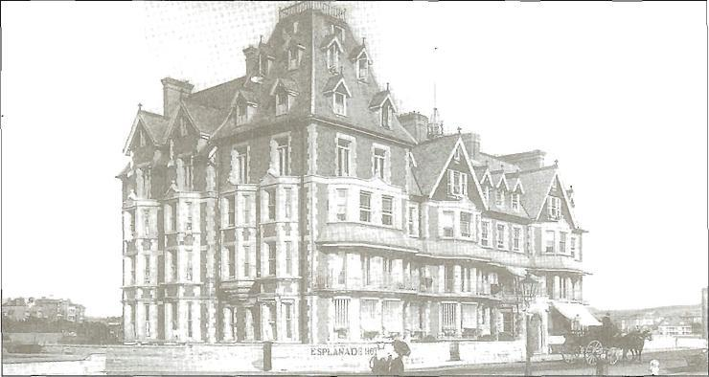

The Esplanade Hotel, Seafront, Seaford

1935
The Provincial Grand Master attended the Installation of W Bro C. (Charles) C. Elliott, a local Doctor, who went on to serve with distinction in World War II, rising to the rank of Surgeon Captain RNR and being award the DSC. W Bro Elliott resided in “Rostrevor” a house in Sutton Park Avenue on the corner of Stafford Road, now the site of Caffyns Garage.

1937

The dates of the Lodge meetings were changed for the last time to those we have today, namely the third Fridays in January through April, September, October (Installation) and November.

The Provincial Grand Master attended the Installation of W Bro F H (Jack) Foster, a local Architect, who also went on to serve with distinction in World War II, rising to the rank of Colonel, Royal Engineers, 1st Division and being awarded the DSO and OBE. W Bro Foster, who went on to become Colonel Commandant of the Sussex Army Cadet Force and a Deputy Lieutenant (DL) for the County of Sussex, was a long serving member of the Lodge and was present at the Installation meeting in 1987, fifty years after his own. W Bro Foster died in 1995.

1938

It is worth noting that the Lodge fees at this time were still 3 guineas (the same as in 1922) but the dining fees had been raised to 7shillings and 6 pence (written as 7/6d and equivalent to 37.5p in decimal currency).

1939

At the beginning of the year, the Lodge moved from the Simons Institute (having met there for 35 years) to the Warwick Rooms, part of the old Gas Showrooms subsequently replaced by the Seaford Central Library – see Meeting and Dining.

The outbreak of World War II brought great changes to the Lodge. For the duration the dress rules were relaxed and winter meetings were often held earlier in the day. Annual membership fees were reduced by two thirds to one guinea (£1.05) and to half a guinea for service personnel.

The cost of the Installation Festive Board had always been included in the annual membership fee but by the late 1930’s this was giving concern especially the expenditure on wines, spirits, cigarettes and cigars. Despite all the best efforts to sort it out prior to 1939, it fell to the stringency imposed by the War to ensure that cover for the Installation Festive Board was suspended from the Membership Fees albeit on a temporary basis. It was restored after the War and was not finally removed from the membership fees until the 1970’s.

1941
With the arrival of Canadian servicemen, Masons among them were once again welcomed into the Lodge. Two Canadians, R.S.M. Roger Strumm and Captain Dennis Oliver were each initiated, passed and raised in the Lodge and although they returned to Canada each remained a member until they died and each regularly sent a Christmas Card to the Worshipful Master of Seaford Lodge. Roger Strumm was made an Honorary Member of the Lodge in 1986 and in Canada became the District Grand Master for the Province of Saskatchewan.
It is because of these two members in Canada that the closing by the Junior Warden has been altered to “of which due notice will be given” as it was considered unlikely that the Brethren in Canada would receive “due notice” of an emergency meeting within the prescribed period.

Bro Arthur Simons Past Provincial Grand Tyler, who had been appointed Tyler in 1906 died in this year and was succeeded as Tyler by his son Mr Leonard Simmons. Mr Leonard Simmons was initiated in March 1941 and held the Office of Tyler as a “Serving Brother” rather than as a member of the Lodge.

1942

At the March meeting, the Lodge performed a Second Degree Ceremony for Heritage Lodge No 5572. At the November meeting it was noted that four members had suffered “material losses” in a recent air raid – while the Brethren “expressed regret” there is no record of any assistance being offered to them!

It was also stipulated by Grand Lodge that as gloves required clothing coupons they were no longer to be worn for Lodge meetings.

1945

Two further Canadians were initiated into the Lodge – Staff Sergeant Charles Pearce at the April meeting and Major Bradley, by dispensation, at a meeting in August. Both retained membership for some time but eventually resigned in the 1970s.

1946

With the end of the War things gradually returned too normal. At an emergency meeting in July Pastmaster’s Jewels were presented to the five Masters installed during the War years.

1947
On 17 October W Bro D W Hopkins was installed as the forty-sixth Master at the Warwick Rooms in Seaford in the presence of the Grand Master, His Grace the Duke of Devonshire KG and the Deputy Provincial Grand Master V.W. Bro F W A Cushman PGD. How these distinguished visitors came to be present is not recorded but only the day before the Grand Master had installed the Very Reverend Alfred Naylor DSO, MBE, MA, Dean of Battle, as the Provincial Grand Master of Sussex at the Town Hall in Hove. Dinner following the Lodge Installation meeting was served at the Esplande Hotel on the seafront (now occupied by Mallets Court).
1948

W Bro D Hopkins instituted the Annual Ladies Festival in this year, with the first one being held at the Esplanade Hotel on 17 November. Details of this inaugural festival have not survived, although programmes for a considerable number of the subsequent Festivals, together with those of over two thirds of the Installation meetings between 1930 and 1990, are stored in the Public Records Office in Lewes.

1950
At the March meeting Captain (Instructor) Akhurst RN (Retd), the Dean of Royal Navy College, Greenwich was elected as a joining member of the Lodge. Captain Akhurst was a member of Navy Lodge No 2612 and was present at the meeting of that Lodge on 4 May 1953 when Bro Admiral of the Fleet HRH Prince Phillip was raised to the Third Degree: he later presented a copy of the summons for that meeting to the Lodge.
In April Seaford Chapter was founded and nine members of the Lodge were among its founder members – these were W Bros R C Beal, F W Pettit, S Moat, D L Petterson, D W Hopkins, L D Mosley, W J Wood, F C Curran, F J Garnett and Bros C E Still, W F Streeter and R S Grey. Seaford Chapter celebrated its own Golden Jubilee in 2000 and in the same year was the first Sussex Chapter to have a banner consecrated.

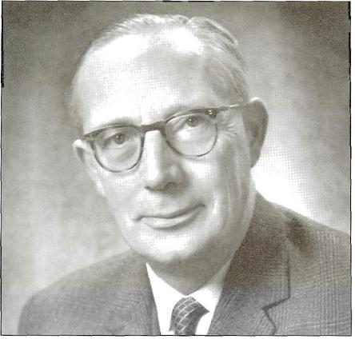

Sir Leonard Barford
Provincial Grand Master Sussex 1977-1990

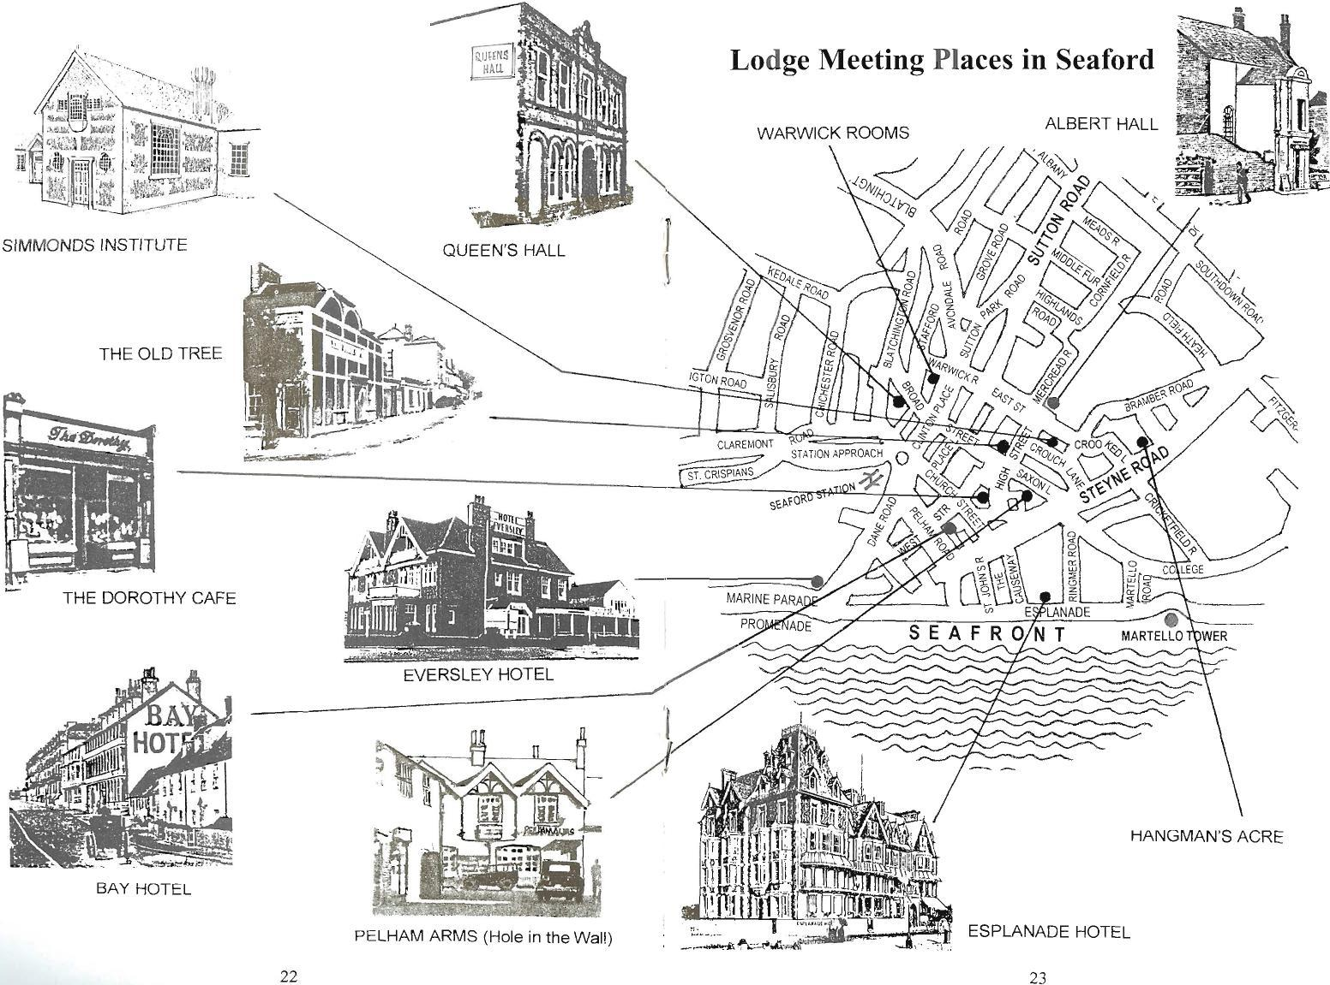

1951

At the January meeting, Mr L E Barford was initiated by his brother W Bro S E Barford. Bro L E Barford had an extremely distinguished Masonic career, being installed as Worshipful Master in 1960 and promoted to Grand Rank as Past Deputy Grand Registrar in 1965. He was appointed Provincial Senior Grand Warden in 1971, Assistant Provincial Grand Master in 1974 and Provincial Grand Master of Sussex in 1977 - a position he held until 1990. He also had a distinguished career in the Civil Service and was Knighted in the New Years Honours List in 1967 when Chief Inspector of Taxes.

1952

The Lodge Jubilee Meeting on 18 February was attended by the Provincial Grand Master, the Very Reverend Alfred Naylor and the Assistant Provincial Grand Master W Bro H Wilfred Aldrich. At the meeting the Lodge’s Tracing Boards, Organ and Deacon’s Wands were dedicated. Dinner was taken at the Esplanade Hotel and the response to the toast “Seaford Lodge” was given by W Bro Louis Mosley PAGDC, then in his thirty-sixth year as Lodge Secretary.
1953
W Bro C. (Charles) E. Still was installed as the fifty second Master – he was a Chiropodist with a practice in Sutton Park Road near the Warwick Rooms. He was also the father of W Bro Quentin Still, who was Master in 1985 – the first of two father and sons who have who have both been Masters of the Lodge.
W Bro Bravery presented to the Lodge a Grand Lodge Certificate issued to a member of the St John’s Lodge No XIII in Secunderabad, India (subsequently renumbered No 234 in the United Grand Lodge of England). An unusual feature of the certificate is the cutting out of the pillars, square and compasses to reveal the pale blue ribbon underneath and the four bars on the certificate represent the four steps already taken by the Lodge member ie Entered Apprentice, Fellow Craft, Master Mason and Past Master. The certificate now hangs in Jerrom Hall Peacehaven.
1954
The Lodge purchased a plot of land at the corner of East Street and Sutton Road for a sum of £750. The aim was to use the land to build a Masonic temple but planning permission was refused by the local Council who compulsory purchased the land in 1965 – see Meeting and Dining.
1957
W Bro F. (Fred) Sexton was installed as the fifty-sixth Master – he was an Off-Licensee of Elm Brewery in Croft Lane, Seaford: the brewery was in the cellar of the building. W Bro Sexton had the privilege of initiating two of his sons into the Lodge, Jim in 1962 and Alan in 1968. Jim Sexton is still an active Mason in Wimbourne in Dorset, where he has been associated with Wimbourne Minster for many years.
1958
Wor Bro P (Pat) Egan was installed as the fifty-seventh Master – he was manager of Findlaters Off-Licence in Station Approach (opposite Seaford Station) and later their High Street Branch. He, like his predecessor, also had the privilege of initiating his son Brian, into the Lodge at a meeting, convened by dispensation on 17 June 1959. Bro Brain Egan was an Officer in the Merchant Navy at the time and the meeting had to be held when he was at home. Bro Brian now lives in Aberystwyth and has been member of a Lodge there for some 24 years.

1959

W Bro H. (Henry) Colley was installed as the fifty-eighth Master: he was Headmaster of Bowden House School in Firle Road, Seaford and had a distinguished War record rising to the rank of Brigadier (Intelligence). He was Secretary of the Lodge for many years and was instrumental in collating many aspects of "Seaford Working”, regularised by W Bro Pettitt.

1960
W Bro Henry Colley introduced the Charge on the Third Apron. The Provincial Grand Master of the time, R W Bro Arthur Jolly indicated that such an address should “not be encouraged” but his successor R W Bro Sir Leonard Barford gave a dispensation permitting the Lodge to continue with the charge - see Seaford Working.
1963
At the March meeting W Bro E Wilcock of Seaford Lodge No 720 of Grand Lodge of Victoria, Australia presented the Lodge with a set of gavels, making a short address in respect of each. In particular he observed that the material used for the Master’s gavel, being from the Outback, represented the enduring quality of the Masonic Fraternity. These gavels are still used in the Lodge today. In return, the Lodge presented them (via W Bro Wilcock) with a perfect Ashlar, made of Sussex “marble” quarried at Plumpton, suitably inscribed with our “united best wishes”.
1964

At the installation meeting, W. Bro F. (Fred) Howe was installed as the sixty-third Master. W Bro Fred holds the Lodge record for the number of Lodges visited in his year as Master having attended 45 Installation Ceremonies – a record which no other Master of the Lodge has come near to emulating. W. Bro Fred is the current Senior Past Master of the Lodge and has been promoted four times in Provincial Grand Lodge, now holding the rank of Past Provincial Sword Bearer. He is also well known for his unique and masterly delivery of the Address to the Wardens, which he has given at the majority of the Lodge’s Installation Meetings in the 1990’s and those of the early part of the twenty-first century.

1965

In this year the new Sussex Working was printed and the Provincial Grand Master intimated that all Lodges should adopt this ritual. This caused concern amongst the older Lodges, Seaford included, who were justly proud of the way they conducted their ceremonies. Such was the feeling that the Provincial Grand Master agreed that there should be a vote by the Brethren of each Lodge to determine whether that Lodge should adopt the new working or remain with their existing working. Seaford Lodge, along with the vast majority of the older Lodges voted to retain their old traditions. However the Provincial Grand Master then decreed that all new Lodges consecrated after 1965 would adopt the “1965 Sussex Working”.

This year also saw the return of the Lodge to Queens Hall for the first time since 1902 – it was used for the Installation meeting in September, as the Esplanade Hotel was not available.
1966
The Lodge fees now stood at 4 guineas and the dining fees for this year were raised to £1/14/0d (written as 34/- and equivalent £1.70p in decimal currency).
This year also saw the resignation of Bro Leonard Simmons who had succeeded his Father as Tyler in 1941. Many warm tributes were paid to Bro Simmons and for the first time since 1906 the Lodge had to find a new Tyler for their meetings.
1967
In this year the Lodge reached its largest membership with 94 subscribing members. This increase in numbers was mainly due to the expansion of Seaford as a retirement town bringing many Masons to the area that were anxious to continue their Masonry locally. With Lodge accommodation tested to the limits, consideration was given to forming a daughter Lodge in Seaford, which was eventually formed in 1973.

This year also saw the celebration of the 250th anniversary of United Grand Lodge and the Installation the HRH the Duke of Kent as Grand Master. A special ceremony to mark the anniversary and to install the Grand Master was held at the Albert Hall on 27 June 1967. One of our members Wor Bro D (Dudley) L Patterson took part in the ceremony in his capacity as Deputy Grand Director of Ceremonies and afterwards presented a copy of the anniversary meeting summons to the Lodge. W Bro Patterson joined the Lodge in 1950 and during his Masonic career was Master of three other Lodges and promoted to Provincial Senior Grand Warden of Sussex in 1963.

On 15 June an Illuminated Address was presented to W Bro H A Jackson on his ninetieth birthday celebrating his 69 years in Freemasonry. He was also presented with a bottle of sherry to drink our health at 9 o’clock

1970

The links with Seaford Lodge No 720 of Grand Lodge of Victoria were cemented when Seaford Lodge No 720 of Victoria, Australia agreed that their Immediate Past Master would wear W Bro Fred Pettit’s Pastmasters Jewel during his year in office. It appears that W Bro Fred had left a package containing this jewel in Australia following his visit to Seaford Lodge but it was not discovered until after his death. Consequently they proposed that the jewel should be worn by their IPM and would “serve to preserve a permanent link between our two Lodges”.

1971

Around this time, the Lodge of Instruction Ladies Supper was instituted. The Presiding Officer was the Junior Warden and the aim was to give the holder of that office and his Lady a rehearsal for their own Ladies’ Night. These “suppers” became quasi-Ladies’ Nights and continued right up to 1991, when due to increasing cost and low attendance they were finally discontinued.

1972
W Bro Ron Beal, who went on to become Master of the Lodge in 1977, presented the Lodge with a Master’s Collar and Jewel in memory of his Uncle, W Bro R C Beal who was Master of the Lodge in 1968. The collar is very distinguished and carries a double chain of silver medallions, each engraved with a Master’s name and his year of office.

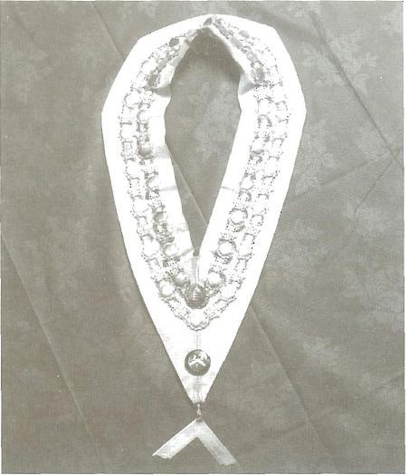

MASTERS COLLAR
SEAFORD LODGE No 2907
Presented to the Lodge in 1972 by Bro Ron Beal in memory of his Uncle,
W Bro R C Beal who was Master of the Lodge in 1968. The collar carries a
double chain of silver medallions, each engraved with a Master's name and his
year of office.

1973

The installation meeting in October was held at the East Brighton Masonic Centre, Jerrom Hall, Peacehaven as the venue at The Downs Seaford had been double booked. At the meeting W Bro John Heritage installed Bro J (Jackie) Bond as the seventy-second Master of the Lodge. However it was not until the following year that the Lodge moved permanently to Jerrom Hall.
Our daughter Lodge, Seven Sisters No 8539 was duly consecrated on 13 November in the Masonic Temple in Brighton. The founder members of Seven Sisters Lodge who were also members of Seaford Lodge were W. Bro Len Howard – the Charter Master, W. Bros Leonard Barford, Stan Chandler, Maurice Parker, Pat Egan, Colin Cathew and Bros David Williams and Vic Flowers. In addition, W Bro John Heritage, a distinguished member of Seaford Lodge, was appointed Tyler of Seven Sisters Lodge - an office he held for over 20 years. Seaford Lodge presented Seven Sisters Lodge with a set of gauntlets and the Officer’s collars.
1974

The Lodge moved to Jerrom Hall, Peacehaven. The first meeting was held there in September – Past Master’s Night. At the same meeting Sir Leonard Barford was congratulated on becoming Assistant Provincial Grand Master.

When the Lodge moved to Jerrom Hall, it took its chequered carpet, its organ and some furniture to furnish the small temple: other pieces of furniture went to furnish a new Lodge overseas.

1977

In February the Pro Grand Master the Rt. Hon. The Earl of Cardogan, installed W Bro Leonard Barford as the Provincial Grand Master of Sussex, at the Dome in Brighton. Our Worshipful Master W Bro M E Parker carried his regalia.

The September Lodge meeting marked, although not precisely, the Seventy-fifth anniversary of the Lodge. At this meeting the Provincial Grand Master and his officers took the Principal Offices. The Deputy Provincial Grand Master V. W Bro Harold Myserscough OBE Past Grand Superintendent of Works, a distinguished honorary member, conducted a dedication ceremony for our Banner, thus rectifying a deficiency that had existed since the banner was presented in the first year of the Lodge’s existence.
1978
Worshipful Brother John Heritage was appointed as Director of Ceremonies, a position he held until 1990. W Bro John was initiated into the Lodge in 1964, installed as Worshipful Master in 1972 and has subsequently been promoted three times in Provincial Grand Lodge; now holding the rank of Past Provincial Grand Registrar. He was also a staunch advocate of “Seaford Working” despite many well-intentioned comments from both within and outside the Province. At most Installation meetings in the 1990s and those of the early part of the twenty-first century he has delivered the Address to the Brethren in a most exemplary manner. He was also Tyler of Seven Sisters Lodge for the first twenty years following its consecration in 1973.

1979
The September meetings are traditionally Past Master’s night and at the Past Master’s night in this year the Provincial Grand Master, Sir Leonard Barford took the Chair, with the Provincial Director of Ceremonies, W Bro Len Howard as Senior Warden and W Bro Archie Berry, our sixty-forth Master, as Junior Warden for the ceremony of passing Bro Quinton Still. A photograph of the Lodge members was taken in the Temple at Jerrom Hall following this meeting and has been included in this booklet.

Officers and Brethren of Seaford Lodge, 1979
Front Row (L to R) Second Row Back Row
W Bro A F Berry Bro B J Wooding Bro L G Williams
W Bro N E Edwards Bro J F Lucas Bro G Lacey
W Bro L E Howard W Bro R F Beal Bro B J Arrowsmith
W R W Bro Sir Leonard Barford W Bro F W Howe Bro B D Earl
W Bro E Shepherd (Worship Master) Bro Q J Still Bro W Morling
W Bro J W Deegan W Bro H T Grigg Bro J Harvey
W Bro H Colley Bro R Stevenson W Bro R James
W Bro L Mann W Bro C T Cathew W Bro J F Heritage
W Bro F C Sexton Bro A J Clarke Bro E J Hensley
Bro K A Stenning Bro A G England
W Bro F A Langridge Bro F J Godfree
W Bro G H Davies W Bro R C Ladbrook
W Bro J V Bond W Bro T C Smoker
W Bro J Cox
W Bro M E Parker
Bro N Collins
W Bro D Comfort
Bro F Berwick
W Bro E Ashby

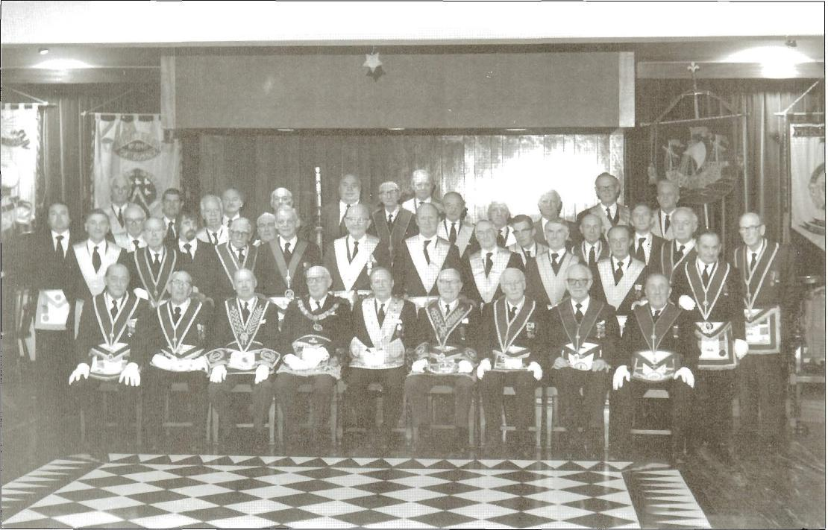

Officers of Seaford Lodge 1979

1980
Once again we welcomed visitors from Australia, when W. Bros Llewellyn and Cameron from Seaford Lodge No 720 of Victoria visited us. Fraternal greetings were exchanged and it was a tradition for many years following that Christmas cards were exchanged between the two Lodges.
W Bro Cameron visited the Lodge several times and was accommodated by W Bro Colin and Mrs Colin Cathew. W Bro John Heritage loaned W Bro Cameron his Past Masters collar and Jewel to wear during his visits, which he wore with much pride as his own Lodge did not use such pieces of regalia. He did however take them back with him to Australia – another piece of Seaford Lodge in Seaford Lodge, Australia.
1981
At the January meeting the Provincial Grand Master presented an inscribed tankard to W Bro H (Harold) Grigg for his many years’ service as Secretary and Treasurer of the Lodge of Instruction. W Bro Harold joined the Lodge in 1960 having been Master of Greenwood Lodge in the Province of Surrey and became Secretary of the Lodge of Instruction shortly afterwards. W Bro Harold died in 1984.

At the April meeting and by special dispensation, W Bro John Heritage raised his son who was a member of Seven Sisters Lodge.

With inflation rising the Lodge and dining fees were increased in this year to £13.50p and £4.60p respectively (a threefold increase in both sets of fees from 1966).
1984
In April, the Provincial Grand Master Sir Leonard Barford installed W Bro L (Len) E Howard was as Assistant Provincial Grand Master. W Bro Len had a distinguished Masonic career – he was initiated into the Lodge in March 1947, installed as Worshipful Master in 1956 and appointed Director of Ceremonies from 1965 to 1975. He was promoted to Grand Rank as Past Senior Grand Deacon in 1976 and appointed Provincial Grand Director of Ceremonies in 1978. He held the office of Assistant Provincial Grand Master until 1987.
1985
For the first time in its history, the Lodge was unable to hold one of its meetings when heavy overnight snow on Thursday 17 January blocked all the roads in the area causing abandonment of the Lodge meeting the next day. The Third degree ceremony of Bro Andrew Bailey scheduled for the meeting on 18 January was held over until the next meeting on 15 February.

1986

The links with Canada were revived once again when Bro G Aldrich of Wentworth Lodge No 116 Canada visited the Lodge and presented, on behalf his Lodge, the inscribed Bible now used for all our meetings.
In this year the founder’s jewel of the first Junior Warden, W. Bro F M Hartung, came to light and is now presented to the Worshipful Master at his Installation, to wear during his year of office. It is worth noting that W Bro Hartung’s name was spelt incorrectly on the petition for the Lodge, being spelt Harting. In view of his unusual name the mistake is not surprising.
The fees were once again increased and now stood at £22 with Country Membership at £15. (Country membership in 1902 meant members outside Sussex and the fee was 1 guinea i.e. £1.05).

1987

Twice in this year meetings of the Lodge had to be abandoned because of bad weather. On 15 January heavy snow once again blocked all the roads in the area and the Lodge meeting on 16 January had to be cancelled.

The devastation of the hurricane on Thursday 15 October caused the Installation meeting on the following day to be cancelled. The Provincial Representative W Bro Victor E Edwards, Assistant Provincial Grand Master, would not have been able to attend the meeting anyway as his car had been flattened on his drive by a falling tree. The Installation of Bro Howard Walton as the eighty-sixth Worshipful Master of the Lodge took place (by dispensation) on 3 November 1987.

1989
The resignation of W Bro J W Deegan CMG, CVO reminded us of how it had fallen to him in February 1952 to inform Princess Elizabeth, at the Tree Tops Lodge Hotel in Kenya, of the death of her father, King George V1 and to acknowledge her as Queen.

W Bro Deegan’s resignation further reminded us that the cloth, which drapes our Secretary’s table during Lodge meetings, is reputed to have been the cloth that hung on the balcony at Buckingham Palace after the Coronation in 1953. Similarly that the upholstery of the smaller kneeling stool that the Lodge brought to the main temple at Jerrom Hall is also said to have come from the same bolt of blue cloth used for the stool on which Her Majesty knelt during her Coronation.

The Provincial Festival in support of the Foundation for the Aged and Sick was held this year and six members and their wives attend the Festival Dinner at the Connaught Rooms in London. As a result of its donations in support of the Festival, the Lodge became a Triple Patron of the Foundation.

1990

W Bro Colin Carthew presented the Lodge with a gavel that Bro G Buckland had brought back from Jerusalem. W Bro Carthew joined the Lodge in 1963 and was Worship Master in 1971. He was Secretary of the Lodge for many years in the 1970s, worked in the Sussex Provincial Office in the 1980’s and was appointed a Grand Officer in 1989 with the rank of Past Grand Standard Bearer. W Bro Colin died in 1996 but will long be remembered for singing the Master’s song at the Installation meetings in our Lodge and in many others.

1991
Tributes were paid in this year to Worshipful Brothers Fred Langridge and John Cox for the service they had given to the Lodge of Instruction (LOI). This tribute emphasised their regular attendance at LOI, both having missed only a handful of meetings from the time they joined the Lodge in 1965 and 1979 respectively and their work as Assistant Preceptors over a period of many years.
The Lodge was also pleased to congratulate the Tyler, W Bro John Scott who had been promoted to Colonel in the Czechoslovakian Air Force. W Bro Scott had flown Spitfires with the Royal Air Force during World War II and with the demise of the Iron Curtain was able to re-establish contact with his home Country. W Bro Scott is the current Tyler having taken up the Office in 1982.
1992
The Lodge presented a Ships Decanter and Whiskey to Bro John Kidman for his services to the Lodge as Organist. Bro John originally joined the Lodge in 1968 previously to which had been abroad for many years especially in India where he was at one time Organist of Calcutta Cathedral.

1993

W Bro Ken Stenning was appointed a Provincial Escort, the first Lodge member to receive this particular appointment since W Bro Len Howard some 20 years previously. W Bro Stenning was initiated in 1973 and was installed as Worshipful Master in 1986. He was a distinguished Director of Ceremonies during the 1990’s and was appointed a Grand Officer with the rank of Past Grand Standard Bearer in 1999. He was also appointed as Assistant Provincial Grand Director of Ceremonies in the same year.
1994
At the October Installation meeting, W Bro Robert Martin LGR became the first Past Master of a Lodge outside Sussex to be installed as Worshipful Master - special dispensation for his installation having been received from the Provincial Grand Master. W Bro Martin joined the Lodge in 1981, was Charity Steward from 1985 to 1990, appointed Past Provincial Senior Grand Deacon in 1996 and has held the office of Director of Ceremonies since 1998.

The annual subscriptions were raised to £55, an increase of £41 since 1981 and showed the effect of inflation on the cost of living at the time.

1996

During the September meeting a presentation was made to Bro L G Williams marking his fifty years as a member of the Lodge – he was a joining member in 1946. In his response Bro Williams gave a brief account of the highlights of that fifty-year period from a personal and Masonic perspective.

This presentation prompted the Lodge to display its Loving Cup (presented in 1906) at every Festive Board and at least once a year to have it suitably charged and passed round the assembled Brethren using the proper toasting procedure.

At the installation meeting in October, W Bro Howard Walton was installed as Worshipful Master, the first Past Master of the Lodge to be re-installed as Master since 1934 – a period of 62 years. It was his misfortune to have his first Installation Ceremony in 1978 postponed due to the hurricane but his Installation in this year proceeded without a hitch.

This year also saw the return of the Founder’s Inner Guard Jewel – it was found in a Seaford Antique shop, purchased and presented to the Lodge by Bro Edmunds.

1997

At the October Installation meeting, W Bro Martin Martin-Woodnutt became the first Past Master of another Sussex Lodge (our Daughter Lodge Seven Sisters No 8539) to be installed as Worshipful Master.

1998

The Lodge qualified as a Patron of the New Samaritan Fund following its contributions to the mini-Festival held by the Province in support of this particular charity.
In view of the approaching Centenary of the Lodge (2002) a Centenary Committee was formed comprising W Bros Robert Martin, John Darvall, John Fuller and Neil Austin. The purpose of the committee was to raise funds and to make the appropriate arrangements for the centenary year including the centenary meeting. As a result a number of social and fundraising events were planned and held over the next few years – these included Quiz Nights, Race Nights, Bowling Competitions and Bar-B-Q’s

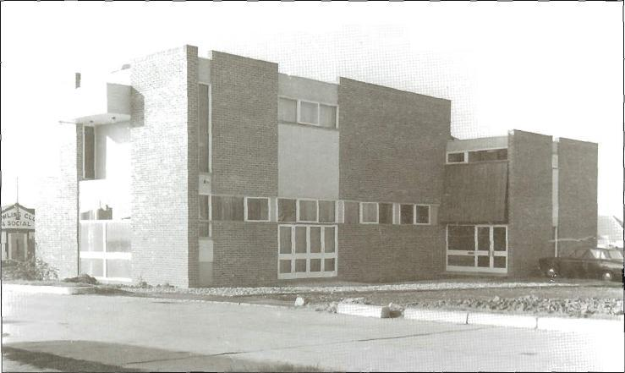

EBMC, Jerrom Hall, Peacehaven, completed 1967

It was also agreed to draft a history of the Lodge and W Bro Ted Shepherd assisted by W Bros John Heritage and Fred Howe agreed to undertake this task.

1999
This year, Seaford Lodge became the sponsoring Lodge of the Association of the Friends of Barford Court, in memory of Sir Len Barford the former Provincial Grand Master and our fifty-ninth Master.
At the October meeting, W Bro John Darvall was installed as Worshipful Master – this was his second term as Master having already been installed as the Ninety-Second Master. The Festive Board following the his installation will be long remembered for its fun and conviviality – so much so that the Provincial Representative, the Assistant Provincial Grand Master W Bro Alan Huntley, did not leave until the end of the meeting as he was enjoying himself so much!
2000
At the installation meeting W Bro Neil Austin, who had been Worshipful Master in 1998, installed his father W Bro David Austin as the ninety-ninth Master of the Lodge. This is the only example in the Lodge’s history of a son installing his father as Master and is an extremely rare event in Freemasonry in general.

2001
The arrangements for the Centenary Meeting and the other activities to be undertaken throughout the year were planned and the Lodge History completed. In addition the Director of Ceremonies, W Bro Robert Martin, finally put the details of “Seaford Working” into regular form.
At the Installation Meeting the one-hundredth Master, Wor Bro Paul Rogers was installed and spoke of his hopes for the special year ahead.
2002
At the January meeting a photograph was taken of the Lodge members for inclusion in the Lodge history. Only four members included in this photograph were also in the 1979 photograph namely: W Bros Fred Howe, John Heritage, Ted Shepherd and Ken Stenning.

An innovation in this year was the “White Table” held after the March meeting when the wives and partners of the Lodge Members joined them at the Festive Board.

The Centenary Meeting was held on 19 April 2002 and attended by the Provincial Grand Master, Right Worshipful Bro Ian Holman Lay and the Officers of Provincial Grand Lodge together with the Lodge Members and their guests. The Worshipful Master, on behalf of the Lodge, presented to the Provincial Grand Master a cheque for £2907 towards the 2004 Provincial Festival for the Royal Masonic Benevolent Institution (RMBI): this brought the Lodge’s current contribution up to 125% of its target.

Meeting and Dining

Meeting Places

Prior to 1974, the meeting places of Seaford Lodge have a somewhat chequered history. For the first two years following its consecration in Queen’s Hall Seaford, (the Drill Hall used by the T.A.), the Lodge held its regular meetings and Festive Boards (in those days called “Banquets”) in the Bay Hotel in Seaford with the Installation Meetings in the Albert Hall, Seaford.

By 1904, the Bay Hotel was proving too small for Lodge meetings (the rooms used must have been very small because at the March meeting the attendance was 15 and at the September meeting only 17 were present) so the meetings were moved to the Simmons Institute, Crouch Lane, Seaford (formally a workshop for Seaford Antiques and now converted into housing units). They continued to be held there until 1939 but the Festive Boards were still held in the Bay Hotel until the 1933 when they were moved to the Eversley Hotel (now the Beachcomber).

In 1939 the Lodge left the Simmons Institute in favour of the Warwick Rooms, part of the old Gas Showrooms in Sutton Park Road (subsequently replaced by the Seaford Central Library) but the Festive Boards still continued at the Eversley Hotel.

In 1962 the Warwick Rooms ceased to be available so the Lodge moved back to the Simmons Institute at the beginning of 1963 with Homestreu Lodge No 3277 kindly tiding us over the two month between the two by the loan of their temple in Bridge Street, Newhaven. Dining however still took place at the Eversley Hotel.

Meetings were also held in other locations, eg Seaford Head Hotel, Terminus Hotel when the Simmons Institute was not available.

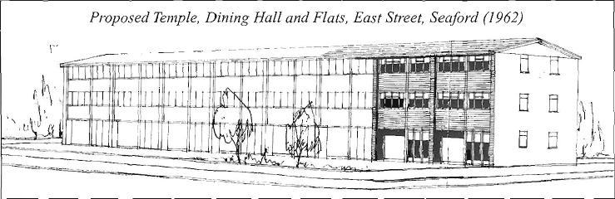

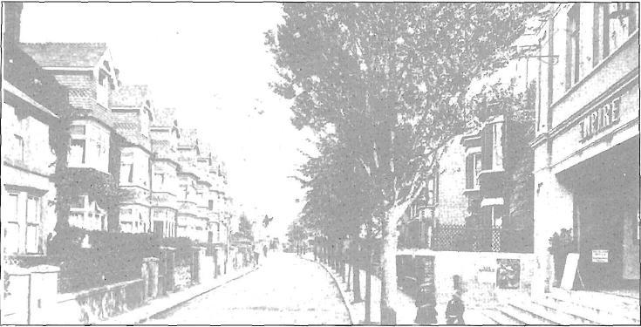

Empire Cinema, Sutton Road

In 1974 we finally moved to our present meeting location East Brighton Masonic Centre, Jerrom Hall, Seaview Road, Peacehaven . We had previously been approached to join the other Lodges in building the centre but as we had always entertained hopes of building our own temple in Seaford we declined but force of circumstances led us to move there in the end.

Our plans to build a temple in Seaford go back a long way. In 1922 a building fund was established with the aim of acquiring our own premises in Seaford and this marked the beginning of a fifty-year search for a permanent location. A significant factor in this desire for a “Masonic Hall” in Seaford was that until the 1970s the majority of the Lodge members and its Masters had lived and worked in or near Seaford which also explains the long reluctance to move to Jerrom Hall.

This search for a suitable location to build our own Temple makes interesting reading. In 1928 a possible site behind Caffyns in Stafford Road (now Stafford Road Garage) was considered but rejected as being too expensive. For the same reason the old Empire Cinema site in Sutton Road (build in 1913 but burnt down in 1939 and never used again) was rejected in 1948 – the asking price was £3250.

In May 1934 the Lodge brought a part of “Hangman’s Acre” in Steyne Road, which is now occupied by Timber Requirements. Part of this area is said to have been the location of the Seaford Gallows and the land was granted to the Hangman for carryout his “trade”. The road leading down to Steyne Road from the High Street, now known as Saxon Lane, was originally Hangman’s Lane.

In May 1954 a site at the junction of East Street and Vicarage Walk was purchased. In 1963 planning permission was submitted for a temple, dining room and a number of flats to be built on the site. However this application was rejected and rejected again following an appeal. In 1964 the Council served a compulsory purchase order on the Lodge and acquired the site in May 1965. The site is now a public car park.

Following the rejection of our planning application, it was considered unlikely that we would gain planning permission to build a new temple in Seaford so the building fund was converted to an Amenities Fund. The aim was to convert an existing building and the search started for suitable premises for this purpose.

In this context, in 1969 the old Fire Station (now part of Safeways) and in 1972 the old Constitutional Club in Coffin Lane were considered as were Clinton Hall in Broad Street and the old Southdown Bus Garage in Dane Road (now part of the Central Health Surgery) but all proved unsuitable for one reason or another.

Meanwhile, in the mid-1960’s several Lodges more local to Peacehaven were pressing ahead in setting up the East Brighton Masonic Centre in Peacehaven and there were strong outside opinions that the Lodge should participate in this venture rather than remain outside. When the Lodge membership became fully aware of this outside opinion, it applied to meet at Jerrom Hall in 1974.

Dining

The festive boards of Lodge meetings in the early days of the Lodge were called banquets. Unfortunately no records remain of those menus but we can get an impression of what they must have been like from the menu of Festive Board at the Installation of the twenty-first Master Wor Bro W P Morgan on 21 April 1922.

This menu shows a five-course meal with a choice of dishes and wines served with each course: in addition there was a comprehensive range of entertainment.

The Festive Boards of the War years 1939-1945 reflected the general rationing and shortages of the times, the Lodge dining at Dorothy’s Café in the High Street, Seaford for 3s.0d (3 shillings – which is equivalent to15p) or 4s.6d (4 shillings and 6 pence equivalent to 22.5p) and sometimes 5s.0d (25p) for Installation meetings.

The menu for our Jubilee meeting in 1952 was very different from that of 1922 but is very similar to those of the present day. This menu shows how times have changed since 1922, especially the entertainment as only the Master’s song now lightens the toasts and speeches.

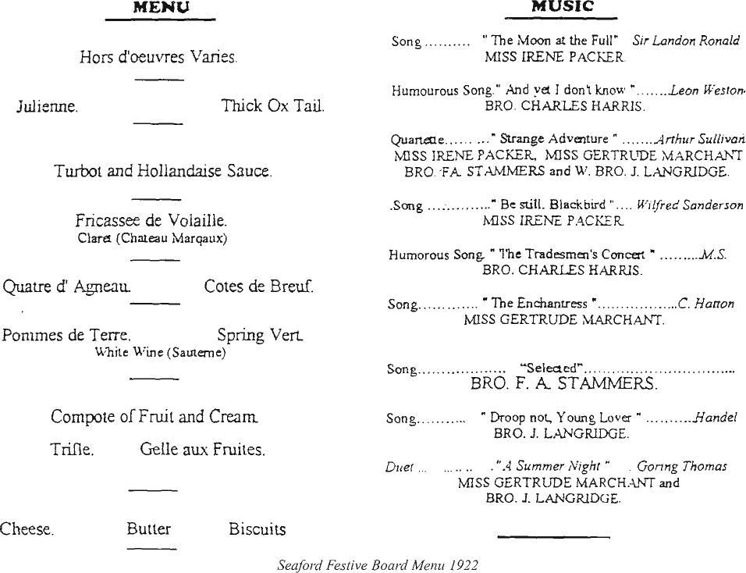

Jubilee  Meeting  FRIDAY APRIL 18th, 1952 | MENU  GRAPEFRUIT MARASCHIN0  -------  CREAM OF TOMATO SOUP  -------  SUPREME OF HALIBUT MORNAY  -------  ROAST GUINEA FOWL  GAME CHIPS  -------  CREAMED POTATOES  BUTTERED FRENCH BEANS  -------  STRAWBERRY FLAN AND CREAM

Seaford Festive Board, Jubilee Meeting, April 1952, Esplanade Hotel

Seaford Working

Seaford Lodge follows the old “Nigerian Ritual as taught at the Emulation Lodge of Improvement”. Why this particular ritual was adopted when the Lodge was formed is not clear but some obvious variations from Nigerian Working have crept in over the years and are now established as “Seaford Working”.

Of these variations, the principle ones are: the extended working tools by the Worshipful Master, Senior and Junior Wardens in the Second Degree, the investiture of the Master Mason’s Badge before the Candidate retires to restore himself in the Third Degree, the Charge on the Third Degree Apron and the positioning and changing of the tracing boards.

The Charge upon the Third Degree Apron was introduced in 1960 by W Bro Henry Colley. This address did not meet with the approval of the Provincial Grand Master of the time but he reluctantly gave permission for it to be part of the Third Degree ceremony with the proviso that only the DC and ADC of the Lodge at that time and W Bro Colley, should deliver it and that no other Brother should continue with the practice. His successor, however, when approached gave his permission for the continuance of the practice and it still forms an important part of the Third Degree ceremony.
The position and changing of “moveable” tracing boards results from the fact that with no permanent home for almost seventy years, the Boards were always place at the midpoint on the floor of the Lodge and a little drill movement developed for the Deacons to change them at the appropriate moment. At the insistence of the Worshipful Master at the time, the Lodge took their tracing boards with them when it moved to Jerrom Hall in 1974 and continued with the practice of placing them in the centre of the Lodge.

The custom of placing the tracing boards in the centre of the Lodge emulates from one of the tasks of the early Tylers, who with the assistance of the youngest (or newest) Entered Apprentice would draw or trace the outlines of the Boards contents on the floor of the Lodge. The Entered Apprentice would then be responsible for cleaning the floor after the meeting. This central position also enables everyone present to see the boards, which is not necessarily the case when they are positioned elsewhere eg at the Secretary's table, and is particularly useful when an explanation is given.
Finally, there can be no doubt about the affection and support of the members of
Seaford Lodge for "Seaford Working" which possibly draws inspiration the following front piece found in an Old Nigerian Ritual and attributed to Brother Rudyard Kipling:
"Then I realised for the first time
what word - and gesture - perfect ritual can
be brought to man"

Seaford Lodge No. 2907
Officers 2001-2002

Worshipful Master | W | Bro. P.K. Rogers
Senior Warden |  | Bro P.A. Darby
Junior Warden |  | Bro. P.A. Howson
Chaplain | W | Bro. J.L. Heritage, BA, BEd, TD, PPrGReg, PM
Treasurer | W | Bro. J.F. Benson, PPrSGD, PM
Secretary | W | Bro. J. Fuller, PPrAGDC (Middx), PM 5843
Director of Ceremonies | W | Bro. R.E. Martin, PPrSGD, SLGR, PM
Almoner | W | Bro. N.J. Austin, PM
Charity Steward | W | Bro. J.R. Darvall, PPrSGD, PM
Senior Deacon |  | Bro. P.C.R. Lee
Junior Deacon |  | Bro. V.B. Gretton
Asst. Director of Ceremonies | W | Bro. P.L. Pain, PPrGSupWks, PM 8169
Asst. Secretary | W | Bro. J. Kirby, MA, PM
Inner Guard |  | Bro. M.J. Churchyard
Steward | W | Bro. E. Shepherd ERD, PPr.GSwdB, PM
 |  | Bro. B.J. Wheeler
 |  | Bro. A. Slater
 |  | Bro. D.J.H. Spring
 |  | Bro. R. Bagley
 |  | Bro. S.J. Hampton
 |  | Bro. M.J. Smith
Tyler | W | Bro. J. Scott, PPrGSwdB, PM 7001
Immediate Past Master | W | Bro. D.J. Austin, PM
Guest Organist |  | Bro. R. Miles, PPrAGStB

Officers and Brethren of Seaford Lodge, 2002
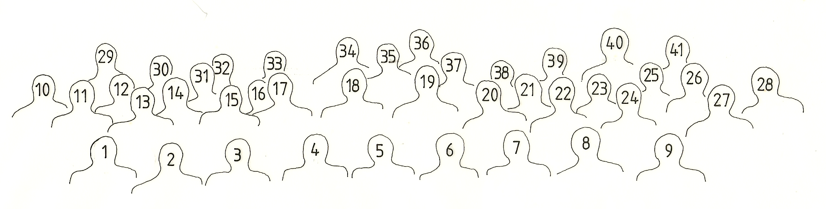

 | Front Row |  | Second Row |  | Back Row
1 | W Bro TF Baker | 10 | W Bro J Scott | 20 | Bro B J Wheeler
2 | W Bro E Shepherd | 11 | W Bro J Kirby | 21 | W Bro P L Pain
3 | W Bro F W A Howe | 12 | Bro R Miles | 22 | Bro V B Gretton
4 | W Bro K A Stenning | 13 | W Bro J R Fuller | 23 | W Bro D J Austin
5 | W Bro P K Rogers (Worshipful Master) | 14 | Bro P A Darby | 24 | Bro M J Smith
6 | W Bro J. L. Heritage | 15 | Bro P A Darby | 25 | W Bro J Kelly
7 | W Bro J. Benson | 16 | W Bro N. J. Austin | 26 | Bro R Bagley
8 | W Bro J R Darvall | 17 | Bro S J Hampton | 27 | Bro A Slater
9 | W Bro R E Martin | 18 | Bro D J H Spring | 28 | Bro P C R Lee
 |  | 19 | Bro D T Flattery

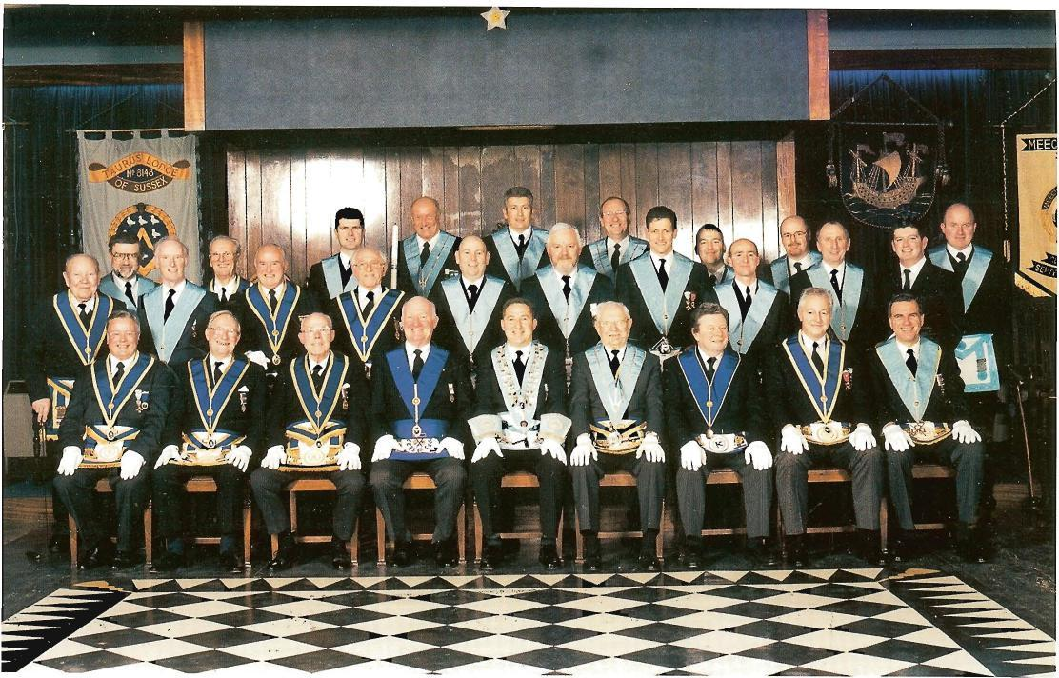

Past Masters of the Lodge

1902 | W Bro. P.S. Lee | 1960 | W Bro. L. Barford
1903 | W Bro. P.S. Lee | 1961 | W Bro. S.E. Borley
1904 | W Bro. J.F. Plaister | 1962 | W Bro. N. Edwards
1905 | W Bro. W.P. Morgan | 1963 | W Bro. G.F.H. Armson
1906 | W Bro. C.B. Gervis | 1964 | W Bro. F.W.A. Howe
1907 | W Bro. T. Stirling | 1965 | W Bro. A.F. Berry
1908 | W Bro. L. Cameron | 1966 | W Bro. N.V.M. Wood
1909 | W Bro. A.T. Snell | 1967 | W Bro. D.H. Williams
1910 | W Bro. A.J. Henderson | 1968 | W Bro. W Urry
1911 | W Bro. J.F. Plaister | 1969 | W Bro. D.A.J. Comfort
1912 | W Bro. P.R. Sanders | 1970 | W Bro. F.N.B. Johnson
1913 | W Bro. W. Mallinson | 1971 | W Bro. C.T. Carthew
1914 | W Bro. F.A. Seymour | 1972 | W Bro. J.L. Heritage
1915 | W Bro. L.D. Mosley | 1973 | W Bro. J.V. Bond
1916 | W Bro. G.T. Godfrey | 1974 | W Bro. F. Langridge
1917 | W Bro. W.T.B. Foster | 1975 | W Bro. T.C.H. Smoker
1918 | W Bro. W.T.B. Foster | 1976 | W Bro. M.E. Parker
1919 | W Bro. F.A. Seymour | 1977 | W Bro. R.F. Beal
1920 | W Bro. W.T. de B. Barwell | 1978 | W Bro. E. Shepherd
1921 | W Bro. F.E. Packer | 1979 | W Bro. A.J. Clarke
1922 | W Bro. W.P. Morgan | 1980 | W Bro. K.A. Stenning
1923 | W Bro. J. Moore | 1981 | W Bro. J.F. Lucas
1924 | W Bro. J.A. Avery-Fowler | 1982 | W Bro. A.G. England
1925 | W Bro. W.J. Wood | 1983 | W Bro. S. Ellis
1926 | W Bro. L.P. Leman | 1984 | W Bro. F.J. Godfree
1927 | W Bro. H.R. Terry | 1985 | W Bro. Q.J. Still
1928 | W Bro. G.T. Godfrey | 1986 | W Bro. J.F. Benson
1929 | W Bro. R. Snushall | 1987 | W Bro. W.H. Walton
1930 | W Bro. G.A. Speechly | 1988 | W Bro. M.C.J. Albrow
1931 | W Bro. F.A. Stammers | 1989 | W Bro. T.F. Baker
1932 | W Bro. W.T. de B. Barwell | 1990 | W Bro. A.P. White
1933 | W Bro. W.C. Marsh | 1991 | W Bro. B.D. Earl
1934 | W Bro. J. Moore | 1992 | W Bro. J. Kelly
1935 | W Bro. C.C. Elliott | 1993 | W Bro. J.R. Darvall
1936 | W Bro. H.A. Jackson | 1994 | W Bro. R.E. Martin
1937 | W Bro. F.H. Foster | 1995 | W Bro. J. Kirby
1938 | W Bro. F.R. Morgan | 1996 | W Bro. W.H. Walton
1939 | W Bro. W.H.B. Shinn | 1997 | W Bro. M.K. Martyn-Woodnutt
1940 | W Bro. J.C. Morling | 1998 | W Bro. N.J Austin
1941 | W Bro. C.W. Legge | 1999 | W Bro. J.R. Darvall
1942 | W Bro. R.C. Beal | 2000 | W Bro. D.J. Austin
1943 | W Bro. F.W. Pettitt | 2001 | W Bro. P.K. Rogers
1944 | W Bro. S.V. Cooper | 2002 | W Bro. P.A. Darby
1945 | W Bro. F.C. Curran | 2003 | W Bro. W. Robinson
1946 | W Bro. J.B. Gilbert | 2004 | W Bro. P.C.R. Lee
1947 | W Bro. D.W. Hopkins | 2005 | W Bro. V.B. Gretton
1948 | W Bro. J.I. Carson | 2006 | W Bro. M.J. Churchyard
1949 | W Bro. F.J. Garnett | 2007 | W Bro. M.J. Churchyard
1950 | W Bro. S.E. Barford | 2008 | W Bro. M.J.Smith
1951 | W Bro. W.F. Streeter | 2009 | W Bro. P. Blake
1952 | W Bro. F.J. Bravery | 2010 | W Bro. A. Hilman
1953 | W Bro. C.E. Still | 2011 | W Bro. S. Curtis
1954 | W Bro. R.S. Gray | 2012 | W Bro. M.Blake
1955 | W Bro. J.A. Merritt | 2013 | W Bro. R.C. Lovelock
1956 | W Bro. L.E. Howard | 2014 | W Bro. I.G. Blakey
1957 | W Bro. F. Sexton | 2015 | W Bro. A. Slater
1958 | W Bro. P.E. Egan | 2016 | W Bro. S.R. Arkwell
1959 | W Bro. H. Colley | 2017 | W Bro. P. Darby
 |  | 2018 | W. Bro P Gibbs
 |  | 2019 | W. Bro M.H Smith
 |  | 2020 | W.Bro A. Coe
 |  | 2021 | W.Bro A. Coe
 |  | 2022 | W. Bro P Barber

